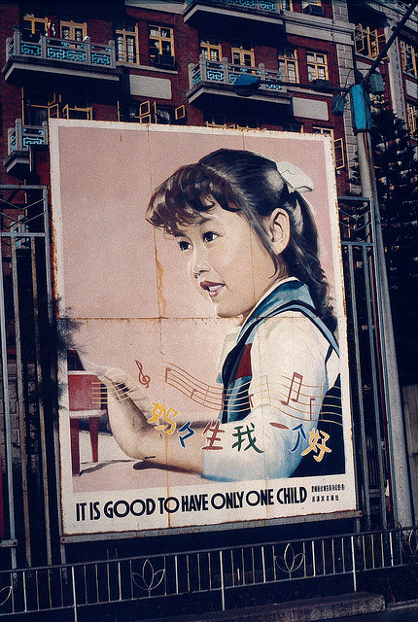
China’s One-Child Policy

- Intro…China’s population
- China’s changing population pyramids

- What is China’s One Child Policy?
  - How does the policy work?
  - How does it encourage families to have only one child?

- Where is China? (use an atlas…old technology!)
  - Locate using words!
  - Draw a sketch map and label any locations mentioned in your case-study.

- When was the policy introduced?
  - Produce a timeline of the policies introduction and any changes made to it since its creation?
  - How has the policy changed over the last 12 months?

- Why was the One Child Policy introduced?

[…this is where you must evaluate the success of the policy by looking at what it aimed to achieve, but what was the socio-economic fall out]

  - What demographic / economic / social environmental situations caused the Chinese government to introduce the policy?
  - Has it been successful…investigate advantages and disadvantages.

- China's one-child policy - success or failure?
- China's pension system waltzes into crisis (14 SEPTEMBER 2010)
- China faces growing sex imbalance (11 JANUARY 2010, ASIA-PACIFIC)
- Ageing China: Changes and challenges (BBC Website)
- Children denied an identity under China's one-child policy
- Sky news reports – October 2013

- Why a two-child policy?

